Numerical Methods

**Report**

Date of the exercise: **14/03/2019**

Exercise: **Theory of Errors**

Group: 2, Team:

Subsection (names):

1. Mateusz Nowotnik

2. Dawid Tomala

**Task 1 –** Calculate the Lagrange remainder

Data:

$$n=2, a=0.5, x_{0}=1, b=1.5$$

$$f\left(x\right)=\frac{1}{2sin⁡(x)}$$

Calculations:

$$r_{n}\left(x\right)=\frac{f^{\left(n+1\right)}\left(z\right)}{\left(n+1\right)!}{(x-x_{0})}^{n+1}$$

$$r_{2}\left(x\right)=\frac{f^{\left(3\right)}\left(z\right)}{3!}{(x-1)}^{3}$$

$$f^{'}\left(x\right)=-\frac{cos⁡(x)}{{2sin}^{2}(x)}$$

$$f^{''}\left(x\right)=\frac{1}{2sin⁡(x)}+\frac{\cos^{2}(x)}{\sin^{3}(x)}$$

$$f^{'''}\left(x\right)=-\frac{5cos⁡(x)}{{2sin}^{2}(x)}-\frac{3\cos^{3}⁡(x)}{\sin^{4}(x)}$$

$$r_{2}\left(x, z\right)=-\frac{5\cos\left(z\right)}{{2sin}^{2}\left(z\right)}-\frac{3\cos^{3}\left(z\right)}{\sin^{4}\left(z\right)}*\frac{1}{6}*({x-1)}^{3}$$

Conclusion:

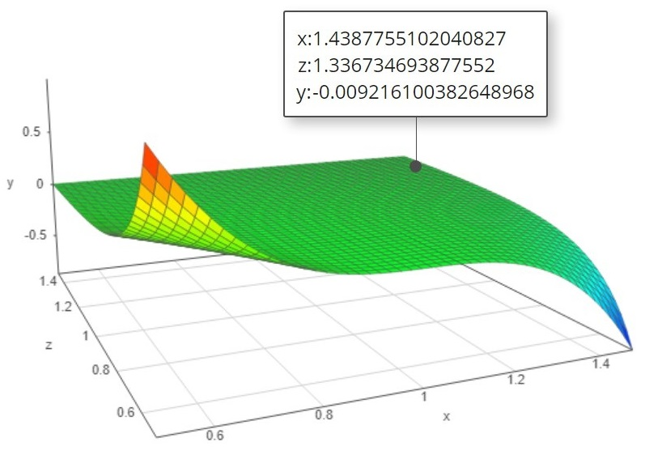

For the second degree Taylor Polynomial of $1/2sin(x)$ on the interval $0.5≤x≤1.5$, centered at $x_{0}=1$, the Lagrange remainder is dependent on the argument of the function $x$ and the value $z$, which sits between $x_{0}$ and $x$**.**

**Task 2 a) -** Find least upper bound of absolute error of object volume

Data:

$$V_{1}=ab^{2}$$

$$V_{2}=πr^{2}h$$

$$a=2.37cm ±0.008cm$$

$$b=3.15cm ±0.002cm$$

$$r=0.85cm ±0.001cm$$

$$h=5.10cm ±0.03cm$$

$$π=3.14cm ±0.0016cm$$

Calculations:

$$V_{1}=ab^{2}$$

$$\frac{∂V_{1}}{∂a}=b^{2}=9.9225$$

$$\frac{∂V_{1}}{∂b}=2ab=14.931$$

$$∆V_{1}=\left|\frac{∂V_{1}}{∂a}\right|*\left|∆a\right|+\left|\frac{∂V_{1}}{∂b}\right|*\left|∆b\right|=9.9225*0.008+14.931*0.002=0.109cm^{3}$$

$$V_{1}=ab^{2}=23.516±0.109cm^{3}$$

$$V_{2}=πr^{2}h$$

$$\frac{∂V_{2}}{∂π}=r^{2}=3.685$$

$$\frac{∂V_{1}}{∂r}=2πrh=27.224$$

$$\frac{∂V_{1}}{∂h}={πr}^{2}=2.269$$

$$∆V_{2}=\left|\frac{∂V_{2}}{∂π}\right|*\left|∆π\right|+\left|\frac{∂V_{2}}{∂r}\right|*\left|∆r\right|+\left|\frac{∂V_{2}}{∂h}\right|*\left|∆h\right|=0.101cm^{3}$$

$$V_{1}=ab^{2}=11.57±0.101cm^{3}$$

$$V=V_{1}+V_{2}=35.086±0.209cm^{3}$$

The total volume of this geometric object is equal to $35.086±0.209cm^{3}$**.**

**Task 2 b) -** Find interval in which the volume of the object is contained

Data:

$$V_{1}=ab^{2}$$

$$V_{2}=πr^{2}h$$

$$\underline{a}=2.31, \overline{a}=2.62$$

$$\underline{b}=3.15, \overline{b}=3.49$$

$$\underline{r}=0.54, \overline{r}=0.67$$

$$\underline{h}=4.93, \overline{h}=5.22$$

$$\underline{π}=3.09, \overline{π}=3.24$$

Calculations:

$$V_{1}=ab^{2}$$

$$\underline{b^{2}}=9.9225, \overline{b^{2}}=12.1801$$

$$\underline{V_{1}}=\underline{a}*{\underline{b}}^{2}=22.921, \overline{V_{1}}=\overline{a}*\overline{b^{2}}=31.912$$

$$V_{2}=πr^{2}h$$

$$\underline{r^{2}}=0.292, \overline{r^{2}}=0.449$$

$$\underline{V_{2}}=\underline{π}*\underline{r^{2}}*\underline{h}=4.448, \overline{V_{2}}=\overline{π}*\overline{r^{2}}*\overline{h}=7.594$$

$$\underline{V}=\underline{V_{1}}+\underline{V_{2}}=27.369cm^{3}$$

$$\overline{V}=\overline{V_{1}}+\overline{V_{2}}=39.506cm^{3}$$

The total volume of this geometric object is contained within the interval **[27.369;39.506].**

**Task 2 c) –** Find the inverse error

$$V=ab^{2}+πr^{2}h$$

$$a=2cm$$

$$b=4cm$$

$$π=3.14cm$$

$$r=1cm$$

$$h=5cm$$

$$\frac{∂V}{∂r}=2πrh=31.4cm^{3}$$

$$\frac{∂V}{∂h}={πr}^{2}=3.14cm^{3}$$

$$\frac{∂V}{∂π}={πr}^{2}=3.14cm^{3}$$

$$\frac{∂V}{∂a}=b^{2}=16cm^{3}$$

$$\frac{∂V}{∂b}=2ab=16cm^{3}$$

$$n=5$$

$$∆x=\frac{∆V}{n|\frac{∂f}{∂x_{i}}|}$$

$$∆a=0.00125$$

$$∆b=0.00125$$

$$∆π=0.004$$

$$∆r=0.00063694267$$

$$∆h=0.00636942675$$